**11 HUMAN BIOLOGY HEART DISSECTION ASSESSMENT**

Name:____________________________ **/24**

This assessment will be completed in class and handed in before you leave

**MATERIALS YOU WILL NEED**

1 sheep's heart Dissecting board or tile

Scalpel Blunt seeker

Blunt forceps Blunt scissors

Antiseptic Plastic gloves

Newspaper

**PROCEDURE AND QUESTIONS**

*Collect your equipment and set out the dissection board/tile on a piece of newspaper.*

*Place the heart in the centre of the dissection board.*

*The heart may be surrounded by a sac called the pericardium. If it is still present remove it by using a scalpel and forceps and peeling it back to expose the heart.*

1. What is the function of the pericardium?

___________________________________________________________________________________

___________________________________________________________________________________

(1 mark)

*Turn the heart and find the pointed end or apex of the heart. This is a part of the left ventricle. The division between right and left ventricles is marked by a diagonal furrow, often covered with fat, on the surface of the heart.*

*Press your finger into the outside walls of both ventricles. The atria are normally small, often wrinkled structures on top of each ventricle. Find each* ***atrium*** *and compare it with each*

***ventricle****.*

2. Describe any differences you feel.

___________________________________________________________________________________

___________________________________________________________________________________

___________________________________________________________________________________

___________________________________________________________________________________

(1 mark)

3. Why is there a difference?

___________________________________________________________________________________

___________________________________________________________________________________

(1 mark)

*The atria are connected to the systemic and pulmonary circulations by veins with thin walls and large lumens. Find these veins. Sometimes the butcher has removed most of the vein and has left only the entrance to the atrium. However, you can still judge the thickness of the veins.*

5. How do the veins and arteries of the systemic system compare with those of the pulmonary system? If yours have been removed write what you would expect to find.

(1 mark)

6. Give a reason for any difference or lack of difference.

(1 mark)

7. Draw a scientific diagram and label the parts.

(3 marks)

*The more obvious blood vessels with thicker walls are arteries. The arteries may branch into smaller arteries but there are essentially two connected to the heart. Try to find these arteries. If you carefully push your finger or a seeker into one of these arteries you should find the path to a ventricle. You should then be able to feel the position of the ventricle from the outside. Do the same with the other artery. This time you should feel your finger or seeker in the other ventricle.*

8. You might have found some resistance to your finger or seeker while pushing it through the arteries. What could have caused this resistance?

___________________________________________________________________________________

___________________________________________________________________________________

(1 mark)

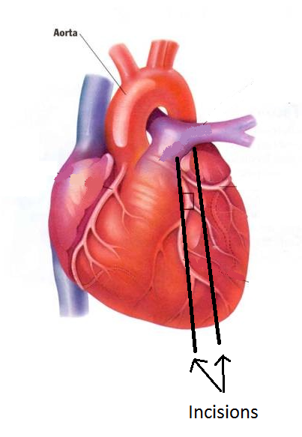Find the diagonal furrow on the outside of the heart. The left ventricle should now be on the right side as you look at the heart.

*Use the scalpel to make a cut about 10mm bellow and parallel to the furrow. Cut until you can see clearly into the ventricle. Repeat this 10mm above the furrow. Again, compare the thickness of the ventricle walls.*

9. Why is one so much thicker than the other?

___________________________________________________________________________________

___________________________________________________________________________________

___________________________________________________________________________________

___________________________________________________________________________________

(2 mark)

*Inside the ventricles you should observe some white cords or thin tendons. These tendons should be connected to flaps of tissue which form the valves at between the ventricles and atria. Use your seeker to try to lift these flaps. Extend your cut if necessary.*

10. What is the purpose of these valves?

___________________________________________________________________________________

___________________________________________________________________________________

(1 mark)

11. What are the names of these valves?

___________________________________________________________________________________

(1 mark)

12. What is the purpose of the chordae tendineae (the thin tendons).

___________________________________________________________________________________

___________________________________________________________________________________

(1 mark)

*Extend your cuts even further so you can see the arteries leaving the ventricles. Use your seeker to try to lift the flaps of tissue which lie along the artery walls just where they join the ventricles.*

13. What would these valves do?

___________________________________________________________________________________

___________________________________________________________________________________

(1 mark)

14. Name these valves.

___________________________________________________________________________________

(1 mark)

*Collect your dissection tools and place them in a beaker for cleaning.*

*Wrap the heart pieces in newspaper and dispose of them in the garbage bag.*

*Rinse the tile*

*Clean up any mess you created on your workspace.*

15. Use the names of the blood vessels, chambers and valves you have learned in this exercise to propose a pathway of blood through the heart.

(4 marks)

16. In which **chambers** and **vessels** would you find oxygenated blood?

___________________________________________________________________________________

___________________________________________________________________________________

___________________________________________________________________________________

(2 marks)

17. In which **chambers** and **vessels** would you find deoxygenated blood?

___________________________________________________________________________________

___________________________________________________________________________________

___________________________________________________________________________________

(2 marks)